Contents

No table of contents entries found.

# Packet Tracer - Who Hears the Broadcast?

**Objectives**

**Part 1: Observe Broadcast Traffic in a VLAN Implementation**

**Part 2: Complete Review Questions**

**Scenario**

In this activity, a 24-port Catalyst 2960 switch is fully populated. All ports are in use. You will observe broadcast traffic in a VLAN implementation and answer some reflection questions.

**Instructions**

## Step 1: Use ping to generate traffic.

1. Click **PC0**and click the **Desktop** tab> **Command Prompt**.
2. Enter the **ping 192.168.1.8** command. The ping should succeed.

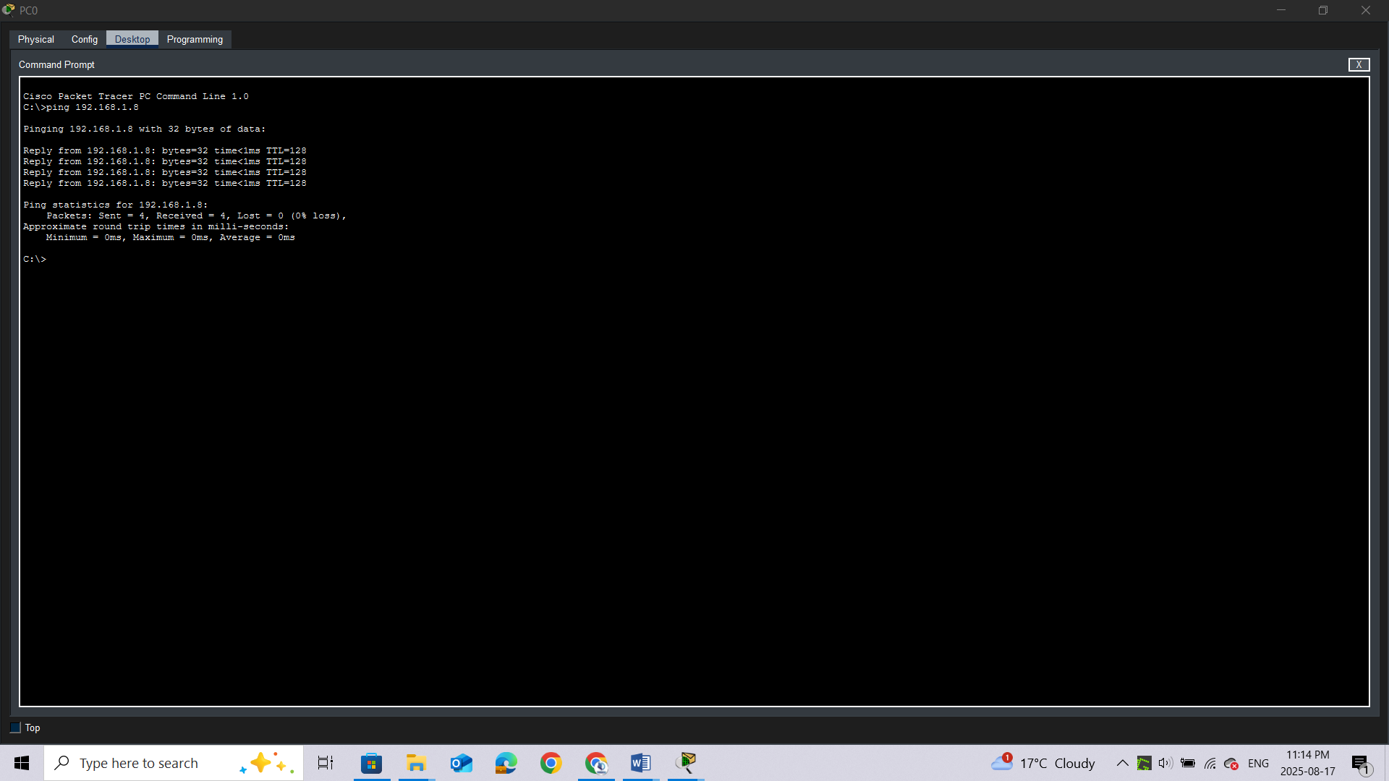

Unlike a LAN, a VLAN is a broadcast domain created by switches. Using Packet Tracer **Simulation** mode, ping the end devices within their own VLAN. Based on your observation, answer the questions in Step 2.

## Step 2: Generate and examine broadcast traffic in a VLAN implementation.

1. Switch to **Simulation** mode.

b.     Click **Edit Filters** in the Simulation Panel. Uncheck the **Show All/None** checkbox. Check the **ICMP** checkbox.

c.     Click the **Add Complex PDU** tool, this is the open envelope icon on the right toolbar.

d.     Float the mouse cursor over the topology and the pointer changes to an envelope with a plus (+) sign.

e.     Click **PC0** to serve as the source for this test message and the **Create Complex PDU**dialog window opens. Enter the following values:

o    Destination IP Address: 255.255.255.255 (broadcast address)

o    Sequence Number: 1

o    One Shot Time: 0

Within the PDU settings, the default for **Select Application:** is PING.

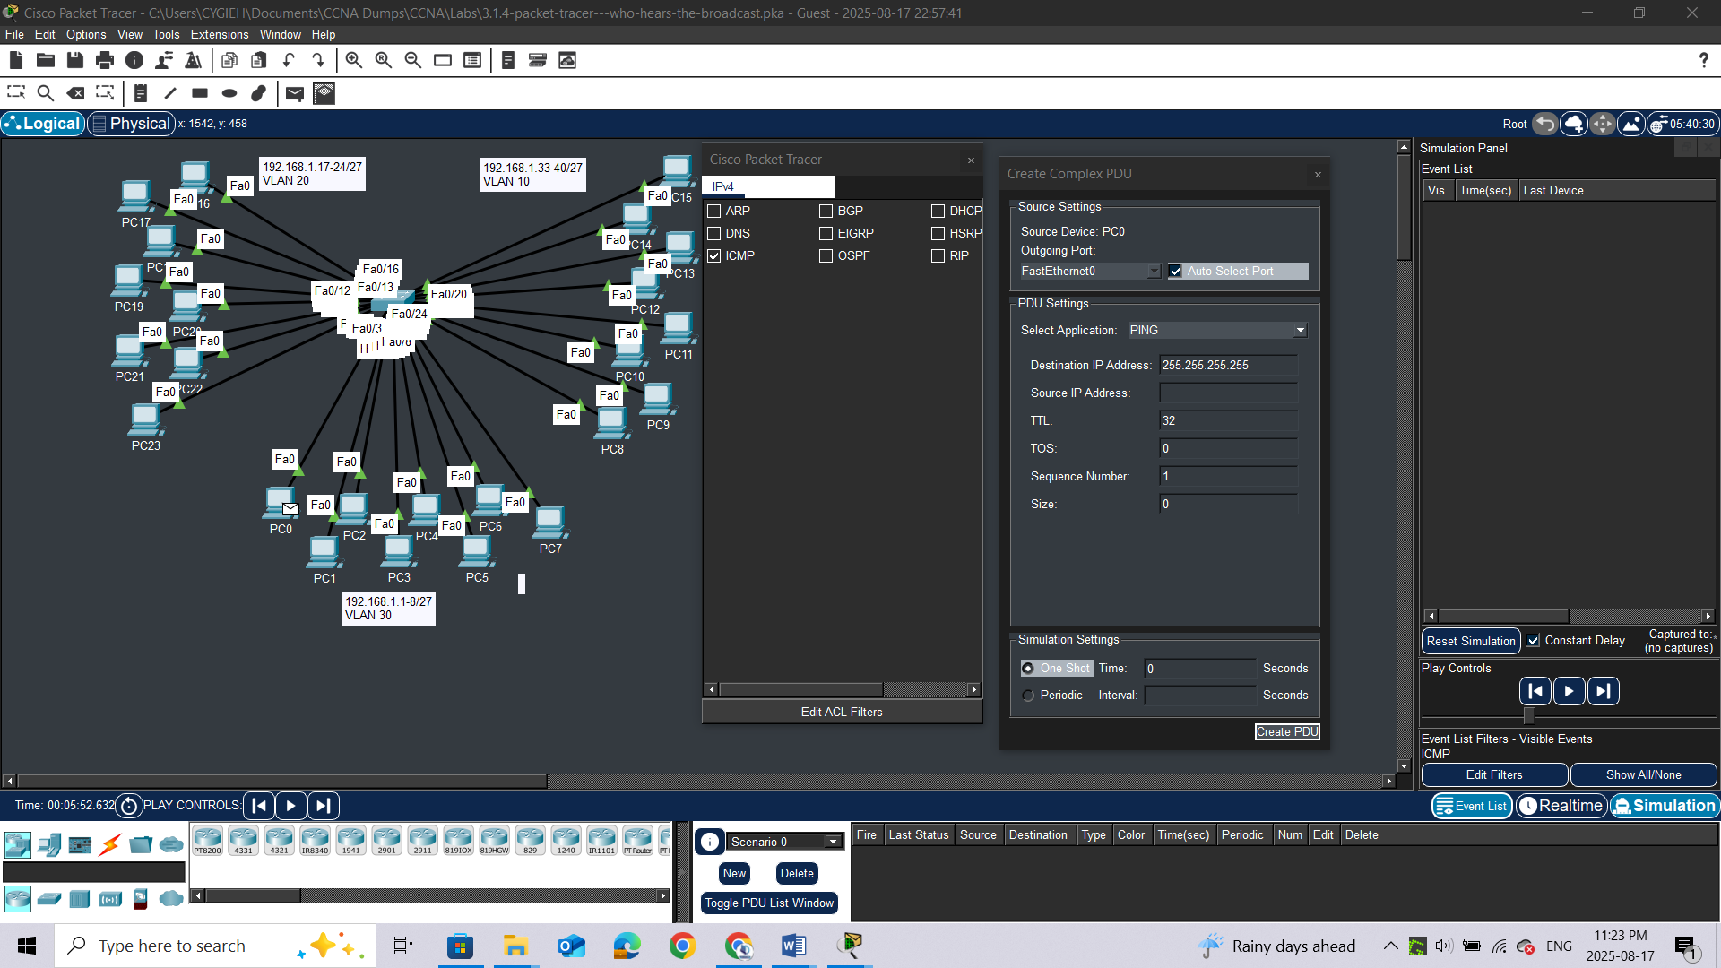

### **Question:**

What are at least 3 other applications available for use? ***DNS, FTP, HTTP, IMAP, NETBIOS, HTTPS***

f.      Click **Create PDU**. This test broadcast packet now appears in the **Simulation Panel Event List.**It also appears in the PDU List window. It is the first PDU for Scenario 0.

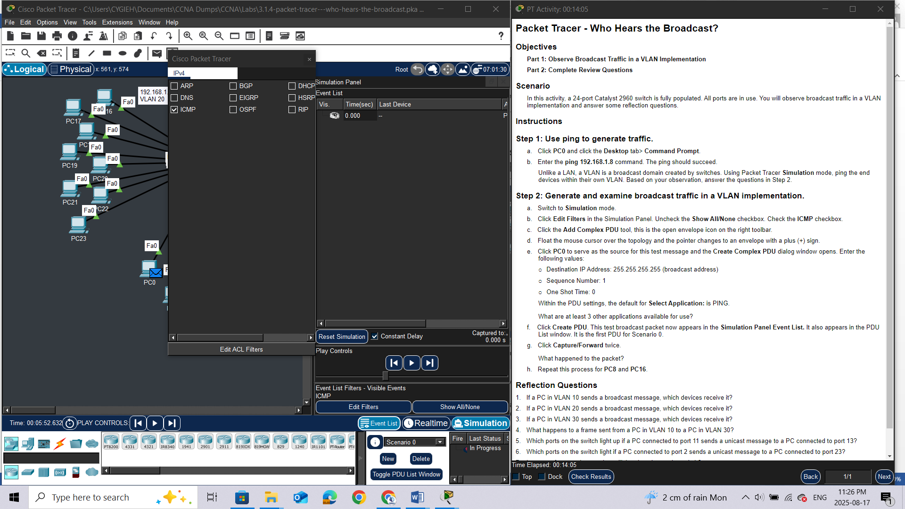

g.     Click**Capture/Forward** twice.

### **Question:**

What happened to the packet?

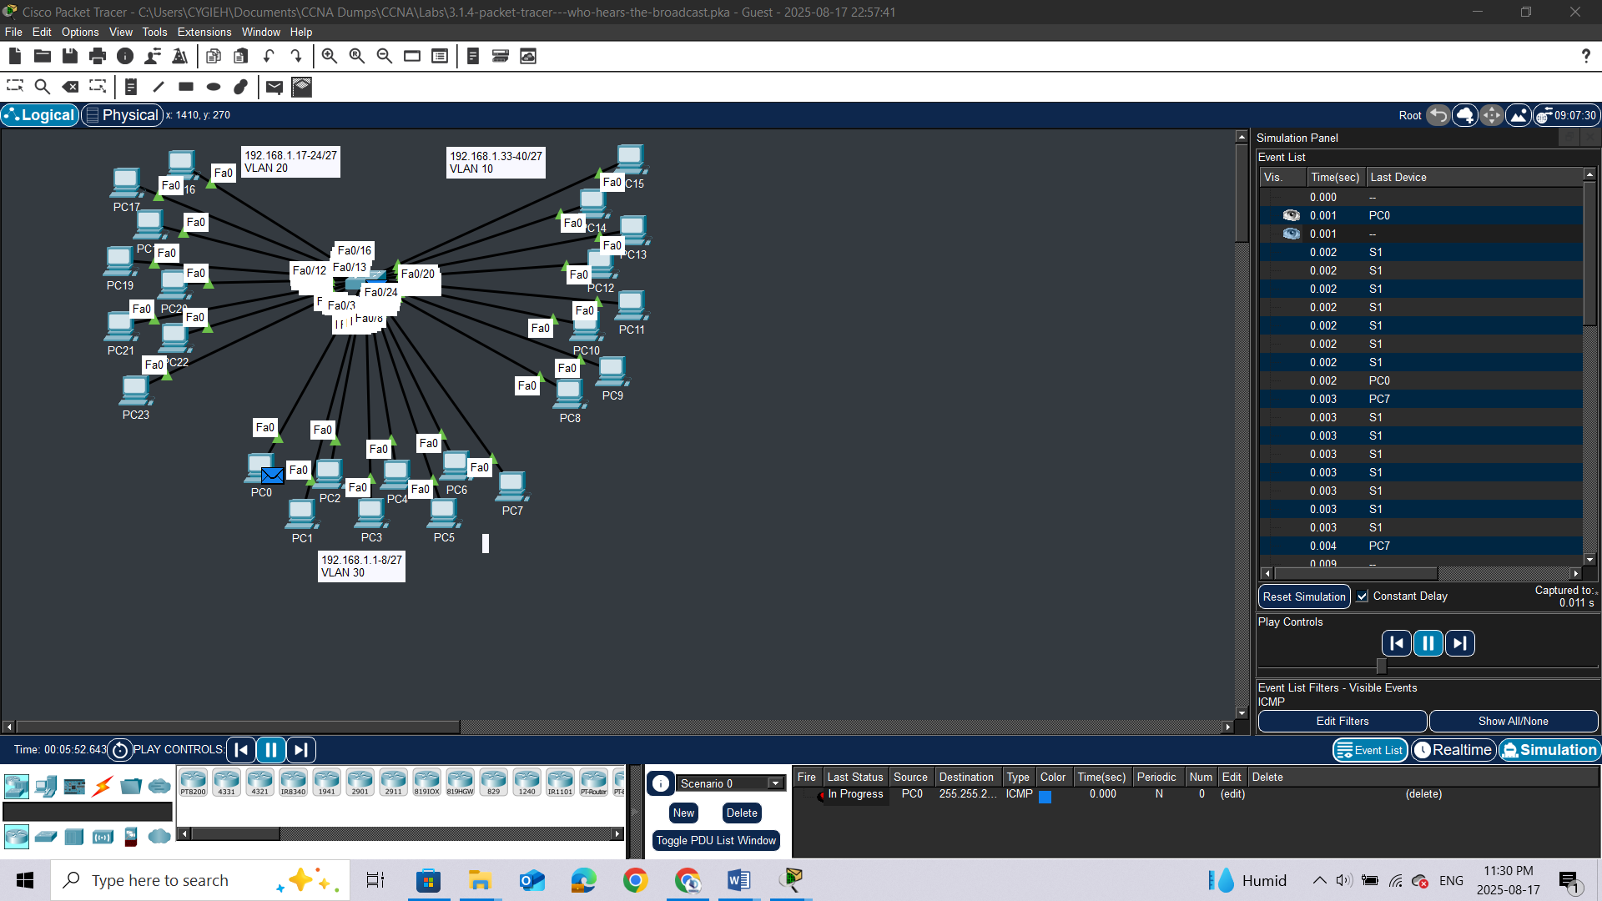

h.     Repeat this process for **PC8**and **PC16**.

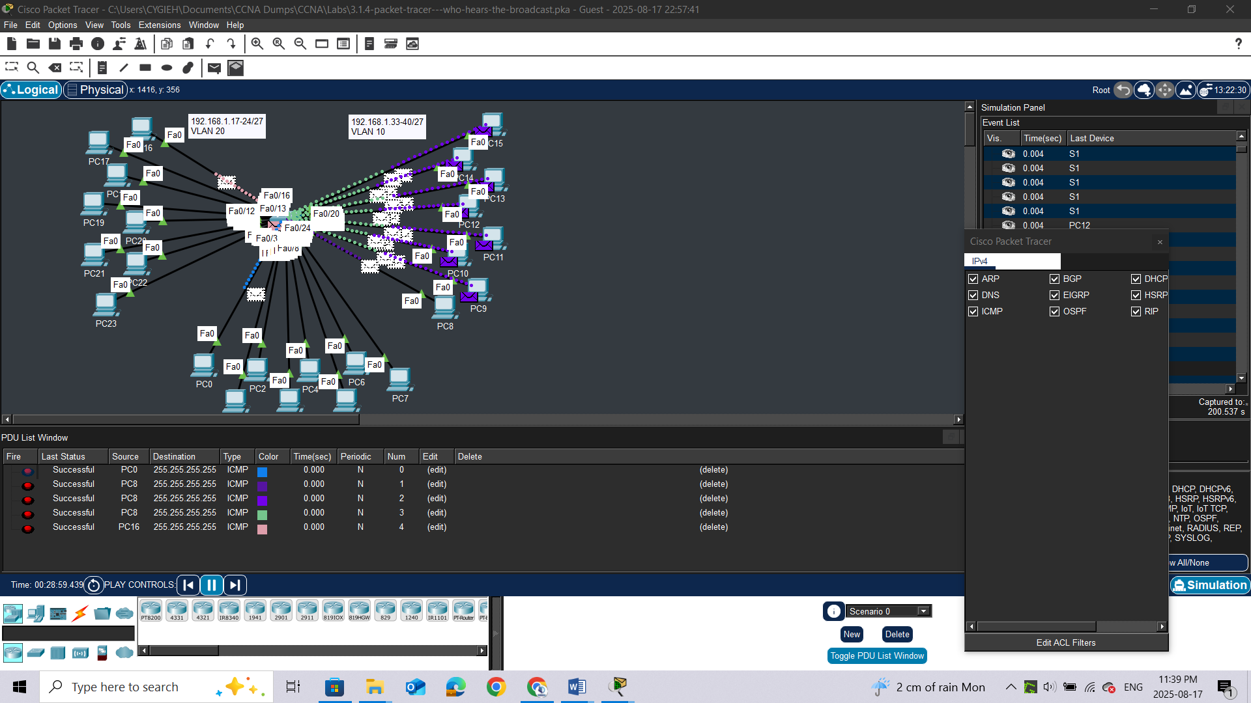

# Reflection Questions

1.     If a PC in VLAN 10 sends a broadcast message, which devices receive it?

2.     If a PC in VLAN 20 sends a broadcast message, which devices receive it?

3.     If a PC in VLAN 30 sends a broadcast message, which devices receive it?

4.     What happens to a frame sent from a PC in VLAN 10 to a PC in VLAN 30?

5.     Which ports on the switch light up if a PC connected to port 11 sends a unicast message to a PC connected to port 13?

6.     Which ports on the switch light if a PC connected to port 2 sends a unicast message to a PC connected to port 23?

7.     In terms of ports, what are the collision domains on the switch?

8.     In terms of ports, what are the broadcast domains on the switch?